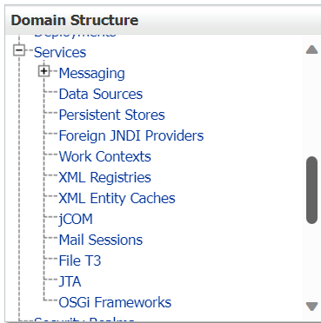

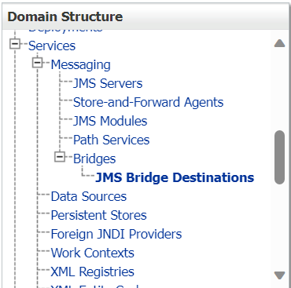

**MESSAGING SERVICES**

**JMS Server Creation:**

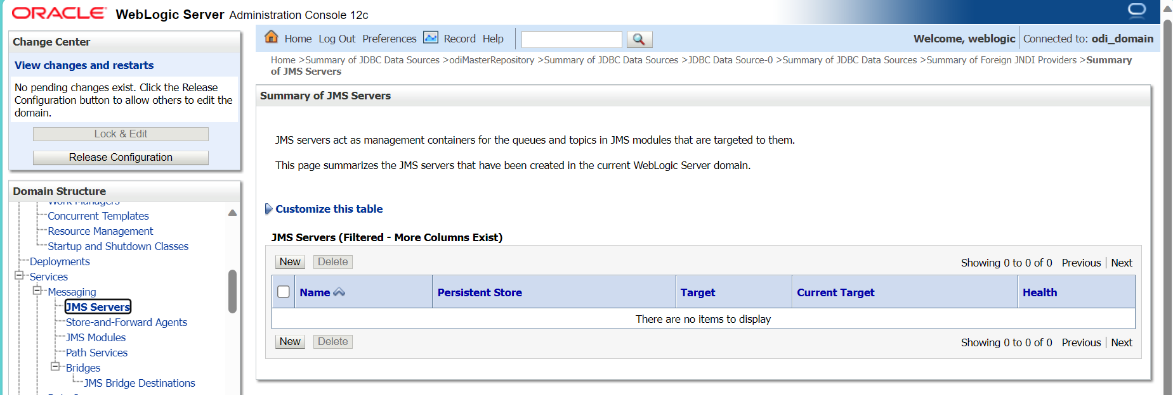

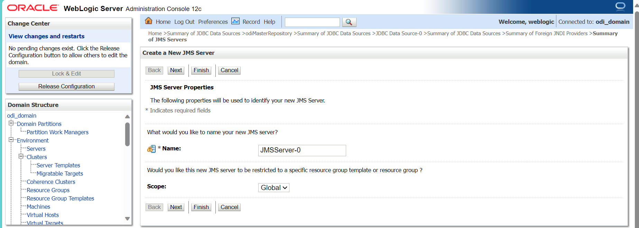

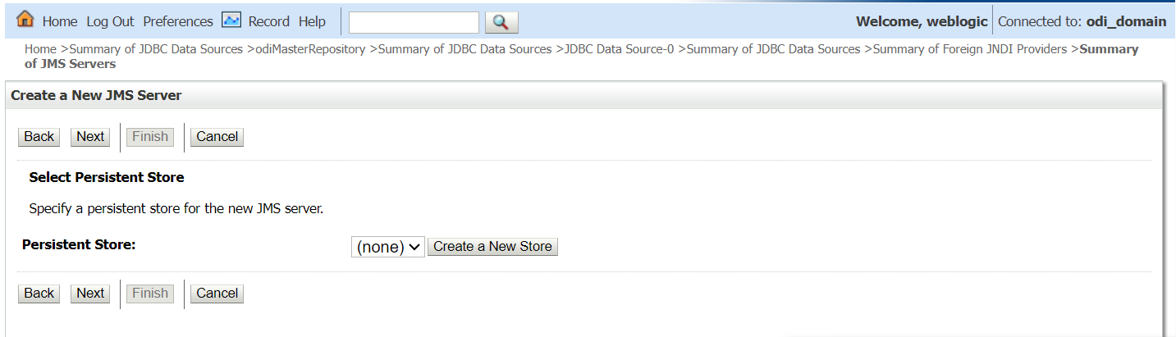

To Create new Store: Select Type of store( JDBC/File Store)

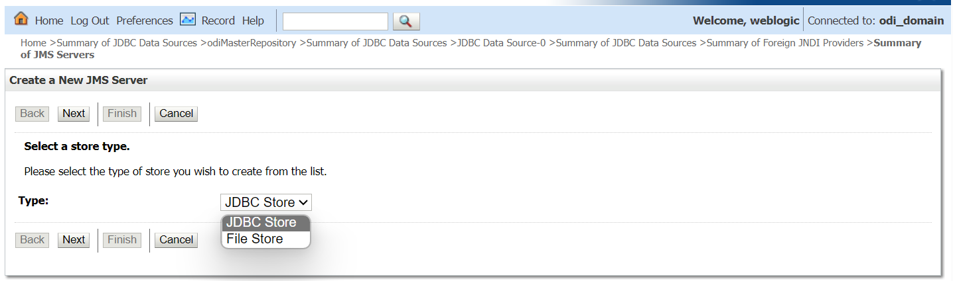

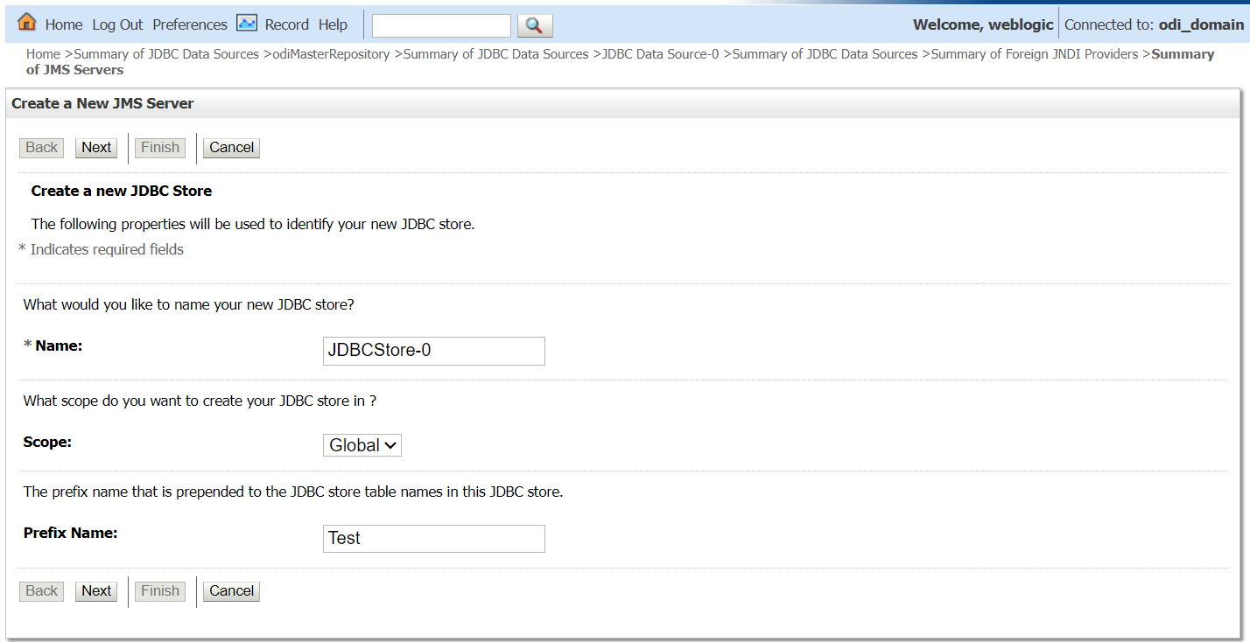

Can Select existing Data sources/create new Datasources

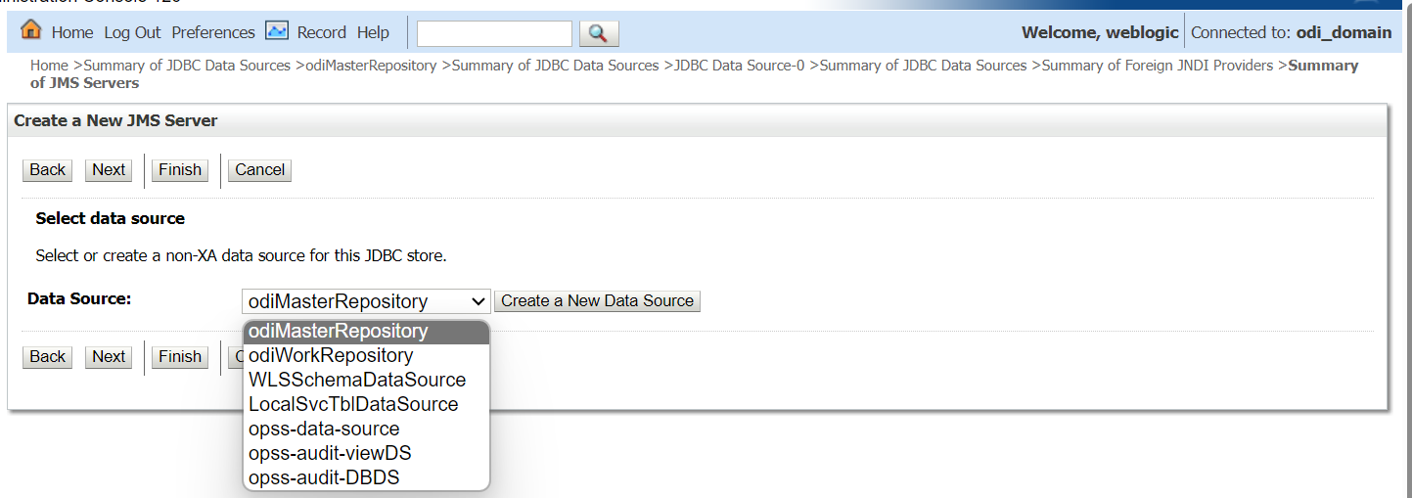

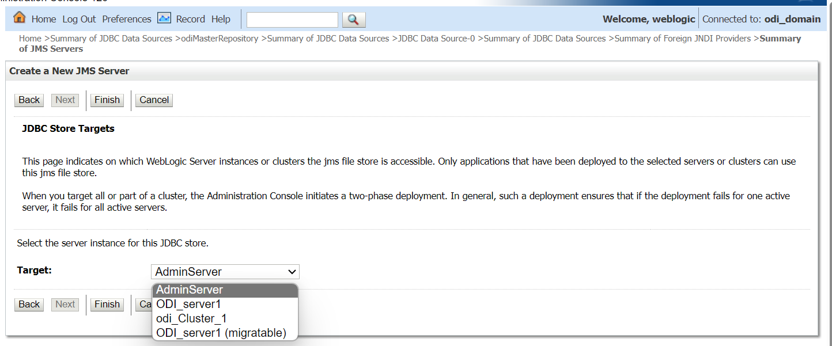

**Creation JMS Modules:**

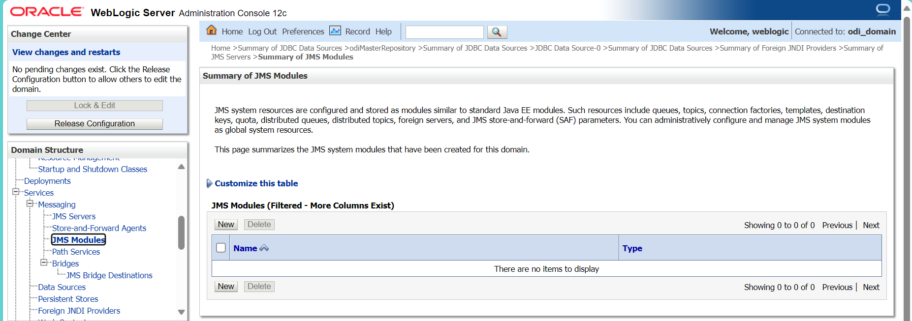

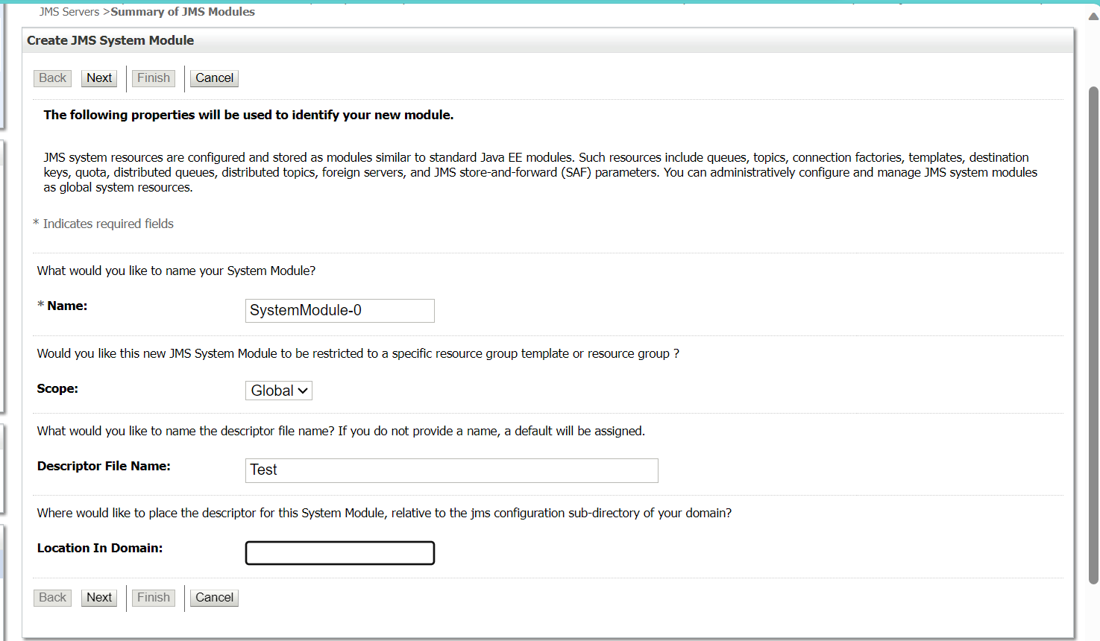

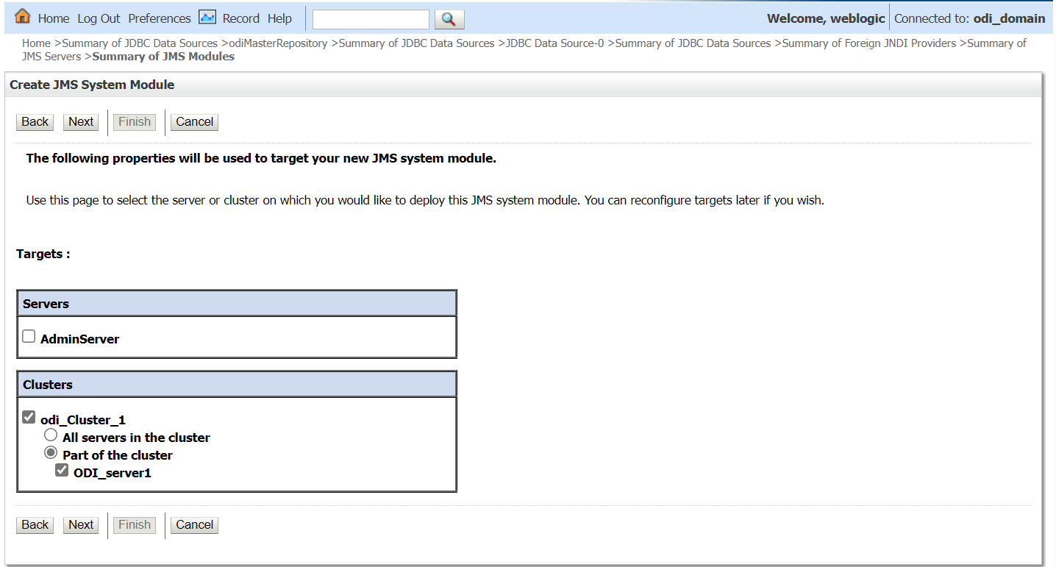

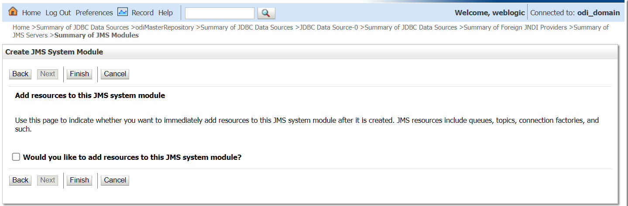

[**Store-and-Forward Agents**](http://192.168.1.93:7001/console/console.portal?_nfpb=true&_pageLabel=JmsSAFAgentSAFAgentTablePage&JmsSAFAgentSAFAgentTablePortlethandle=com.bea.console.handles.JMXHandle%28%22com.bea%3AName%3Dodi_domain%2CType%3DDomain%22%29)**:**

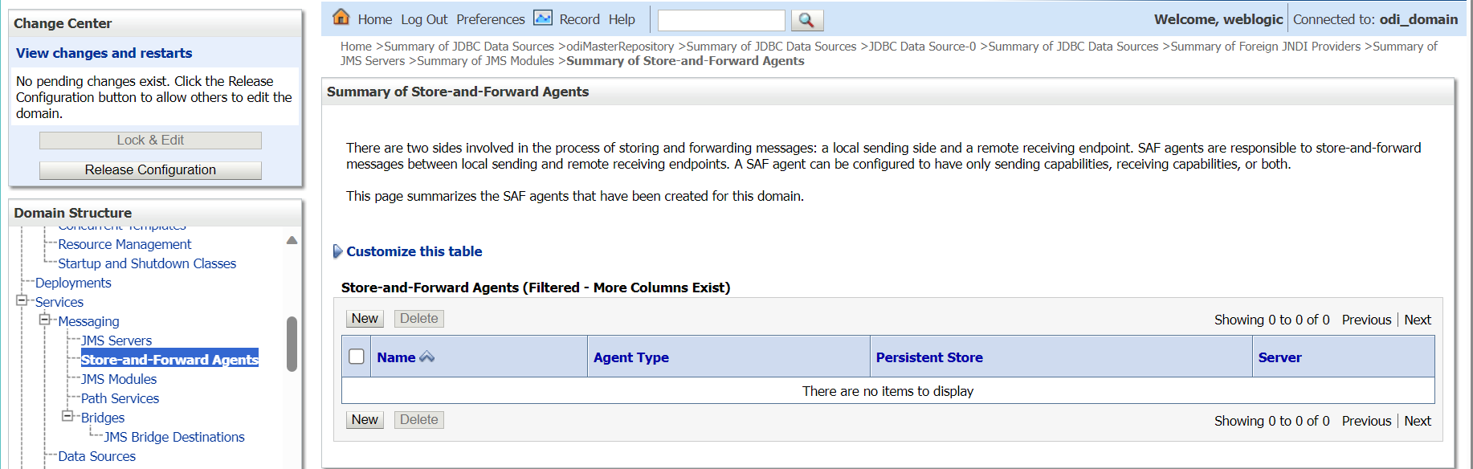

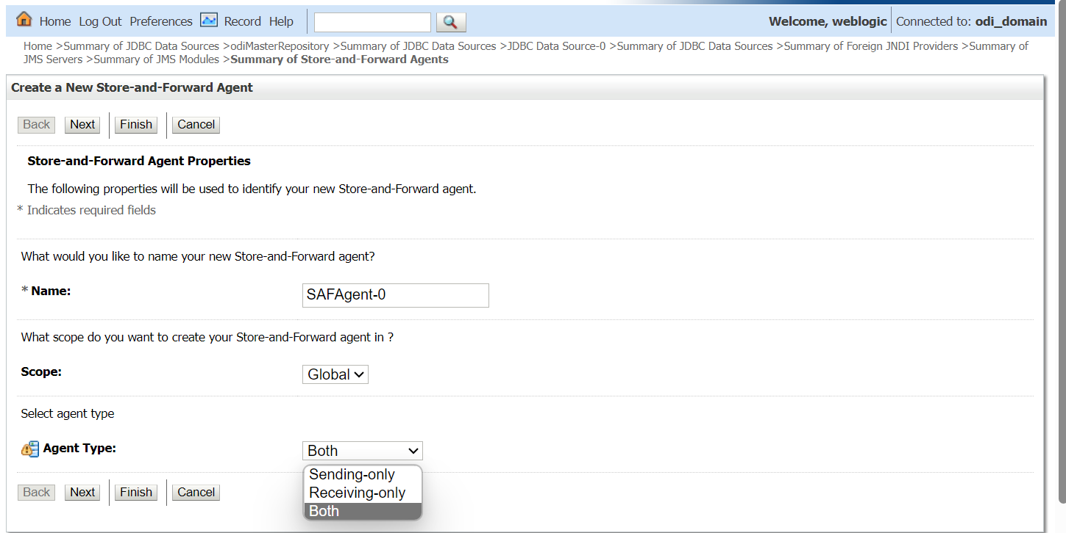

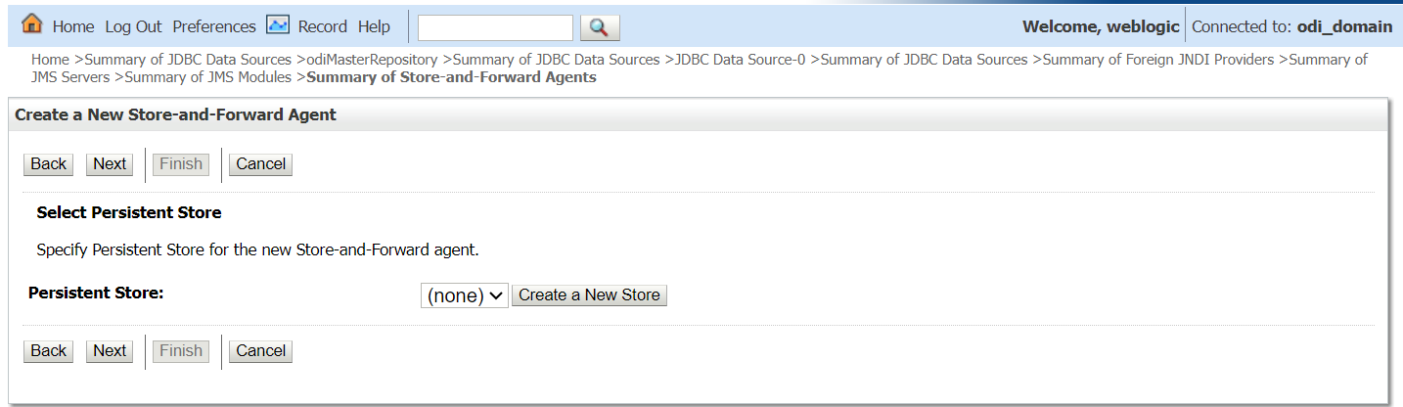

**Can Create New persistence store/select Existing Store**

* **Creating persistence store on SFA**

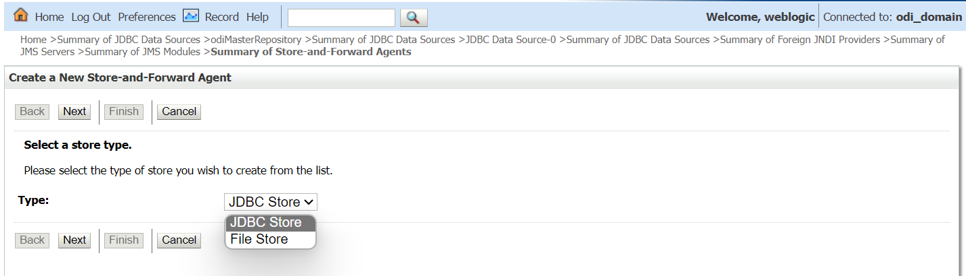

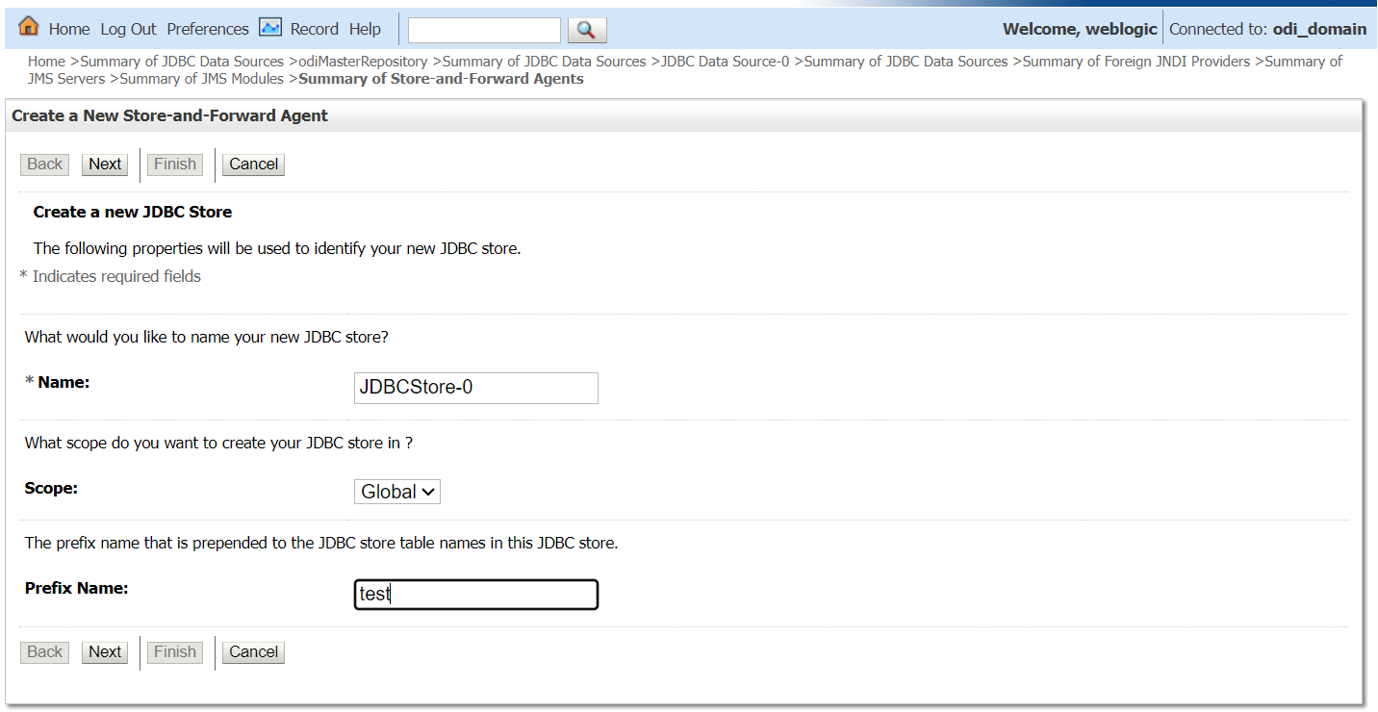

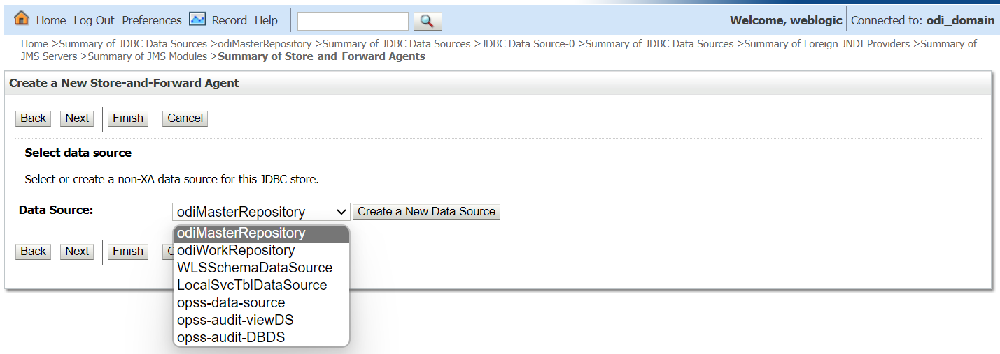

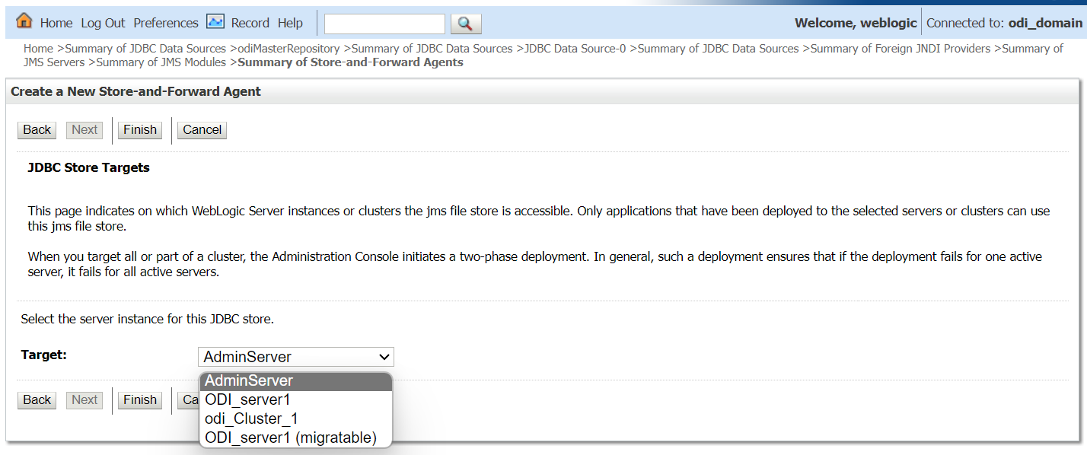

**Path Services:**

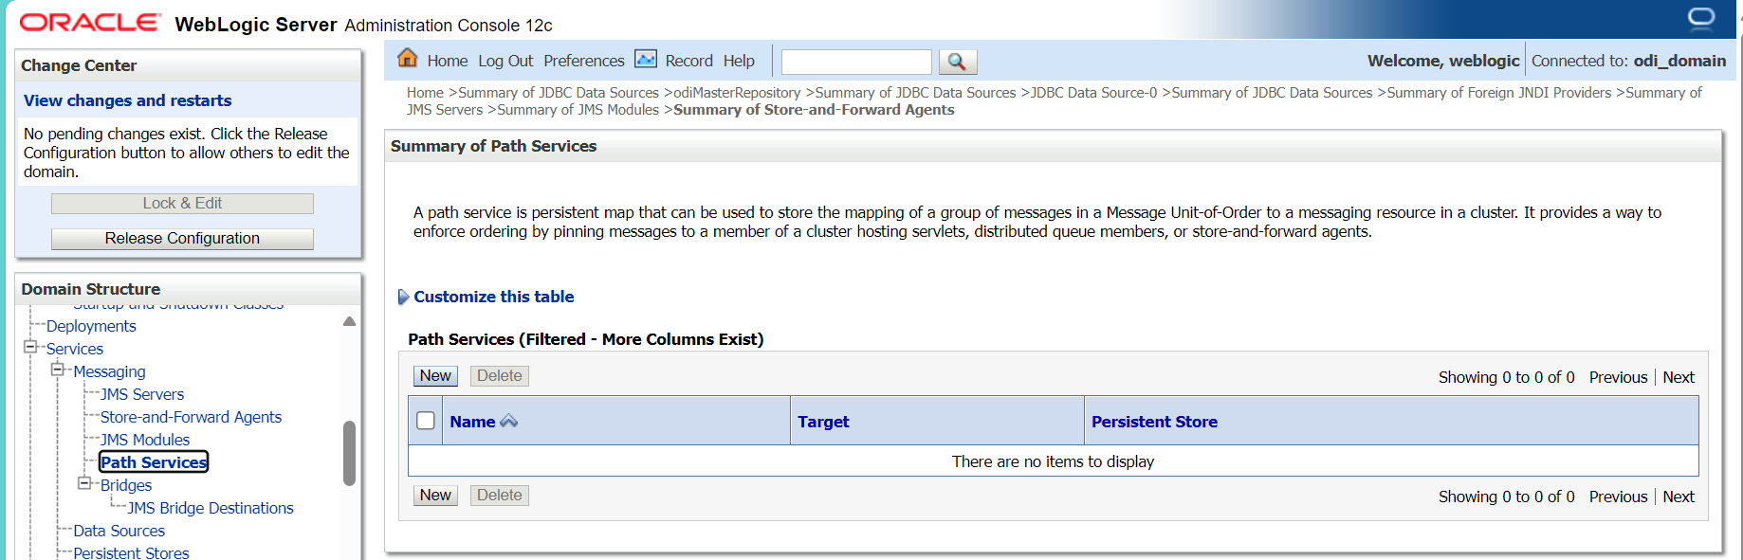

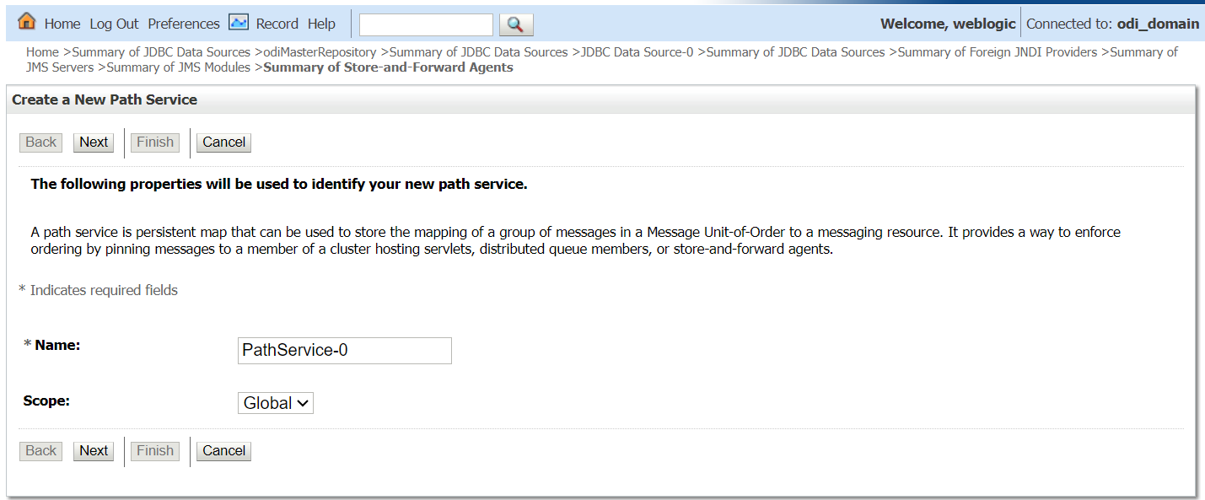

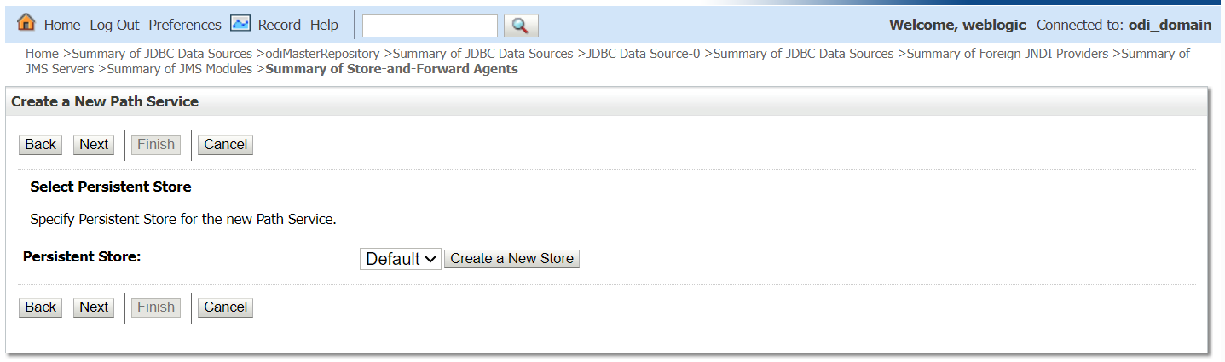

**Can Create New persistence store/select Existing Store**

* **Creating persistence store on SFA**









**BRIDGES:**

[**JMS Bridge Destinations**](http://192.168.1.93:7001/console/console.portal?_nfpb=true&_pageLabel=JmsBridgedestinationJMSBridgeDestinationTablePage&JmsBridgedestinationJMSBridgeDestinationTablePortlethandle=com.bea.console.handles.JMXHandle%28%22com.bea%3AName%3Dodi_domain%2CType%3DDomain%22%29)**:**

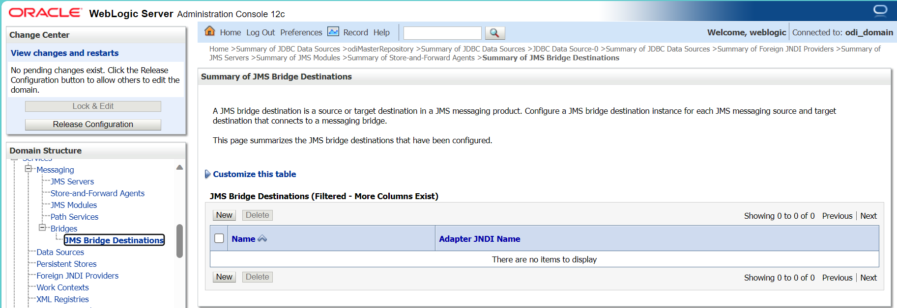

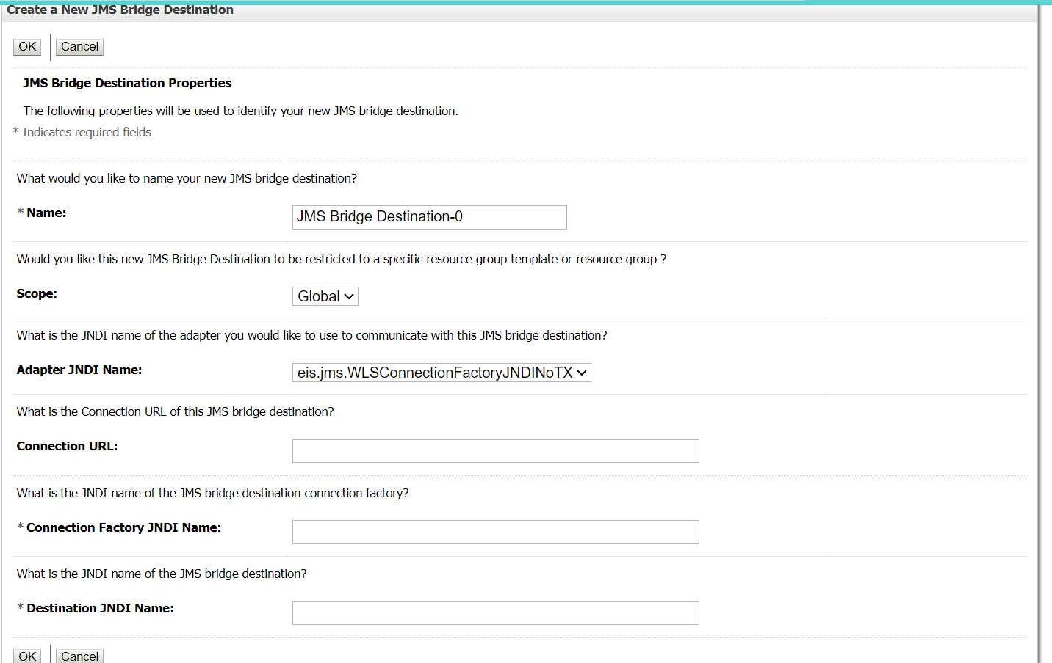

**DATA SOURCES**

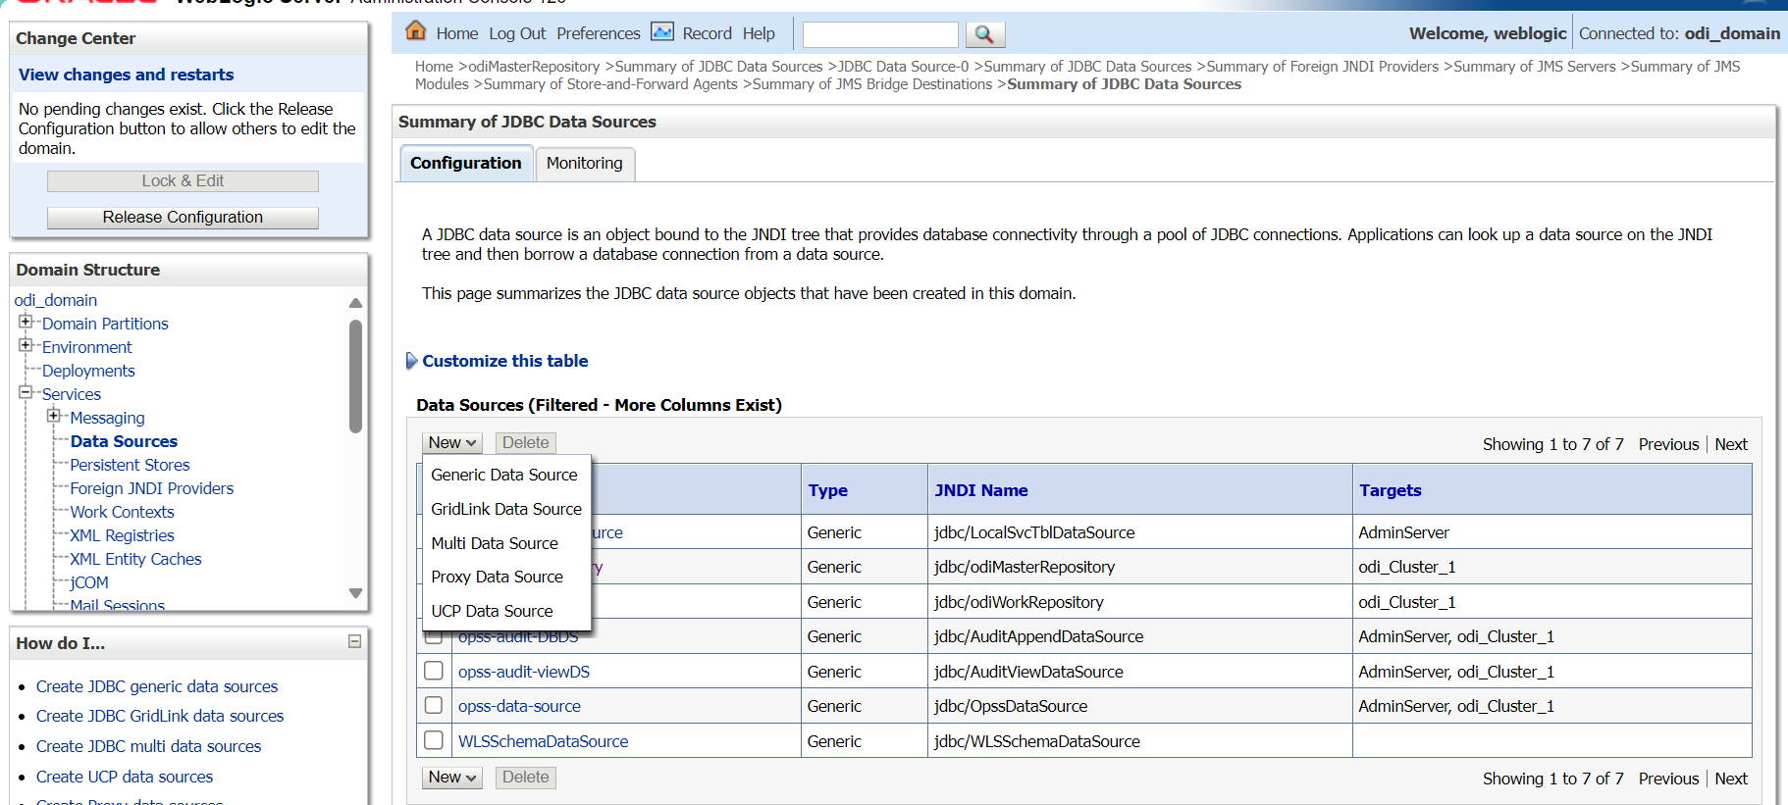

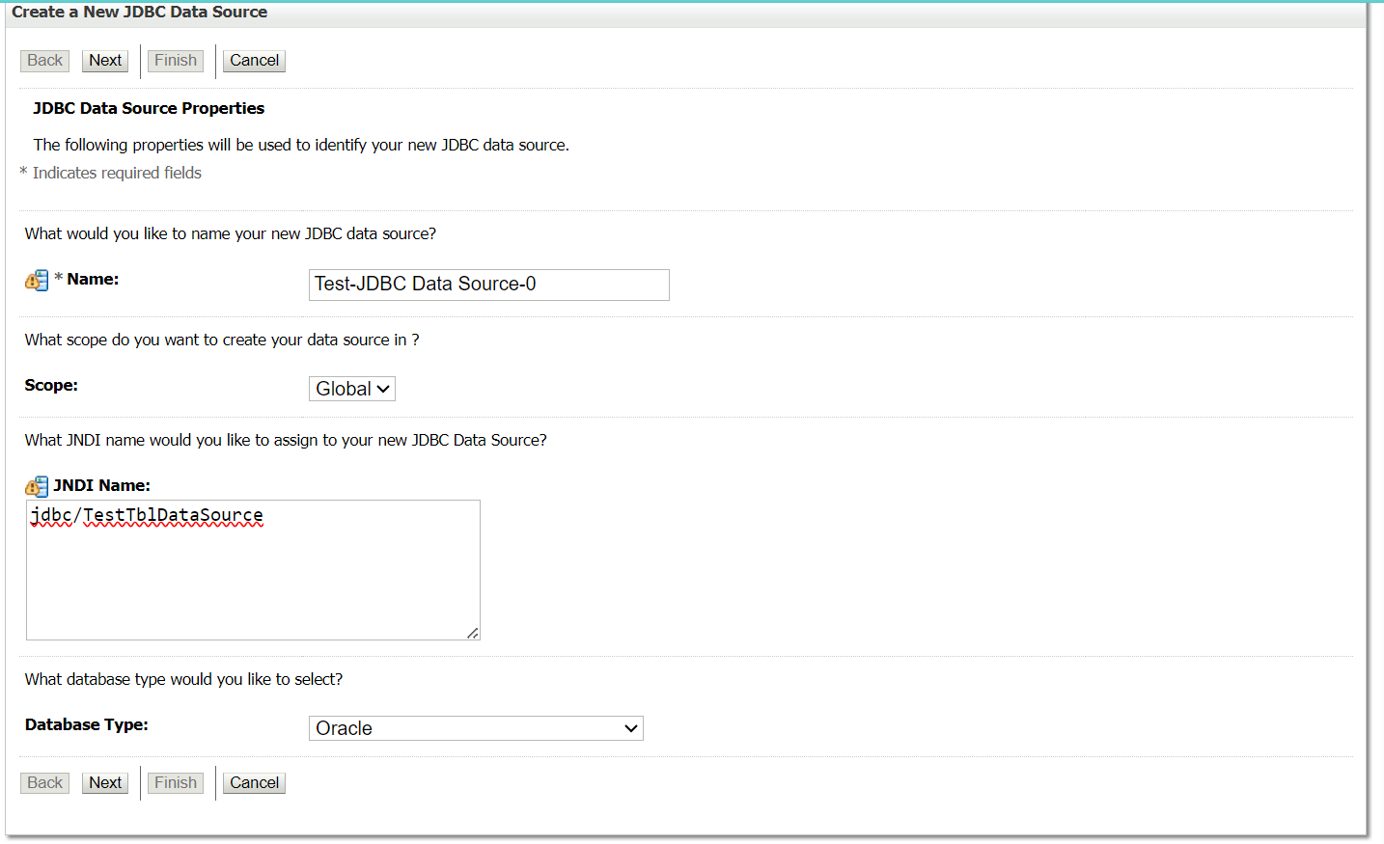

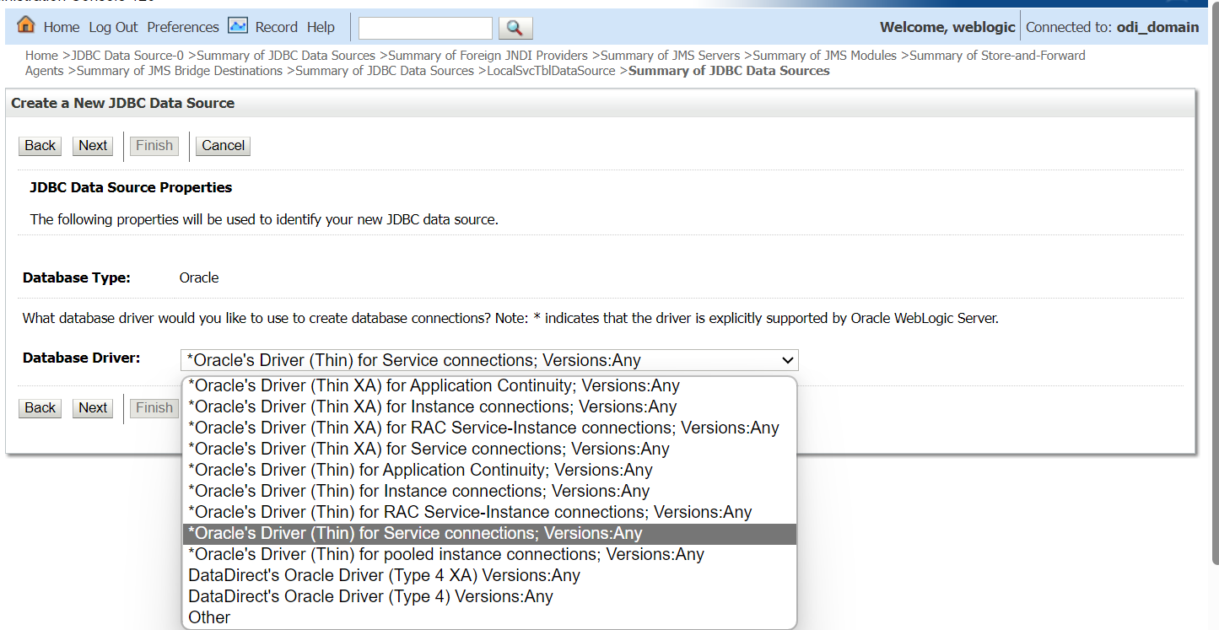

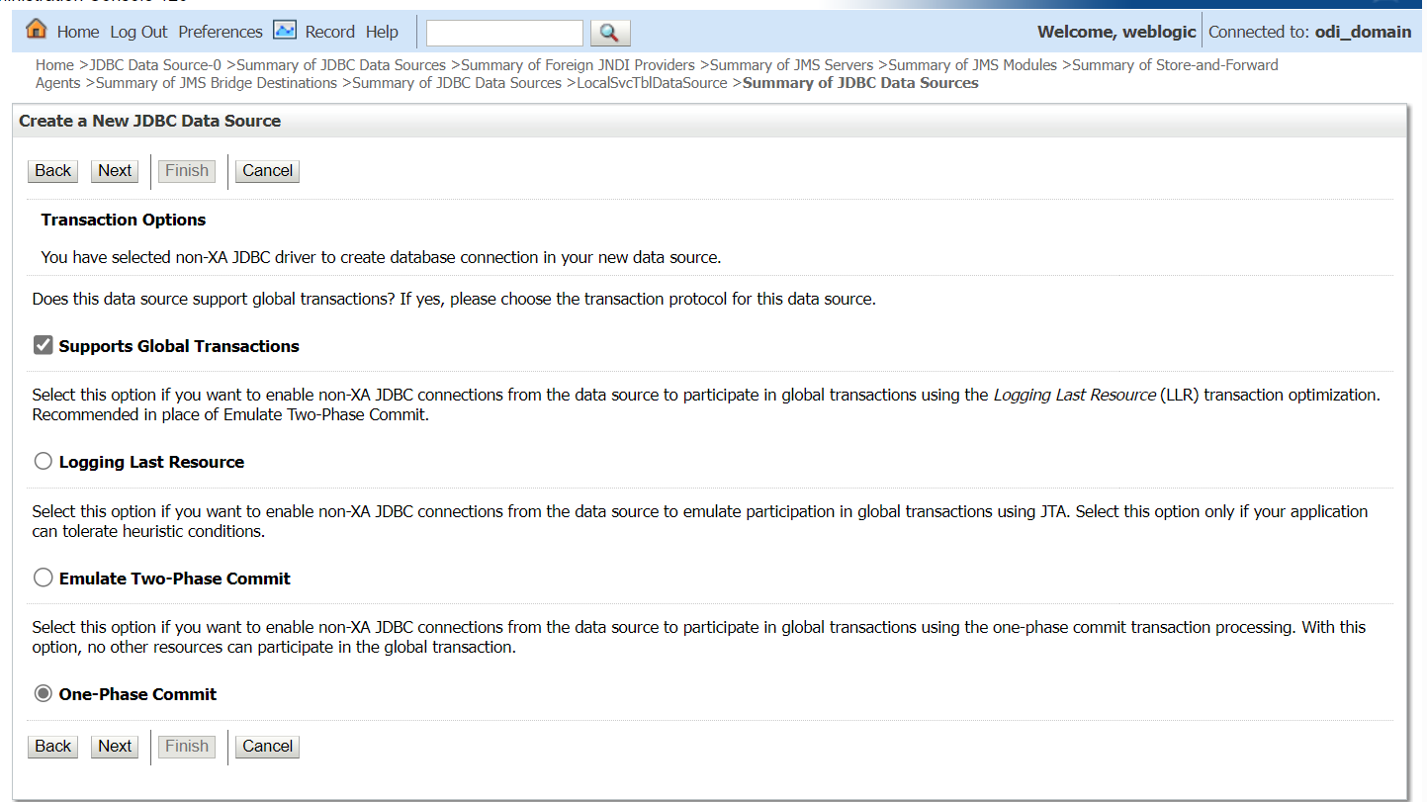

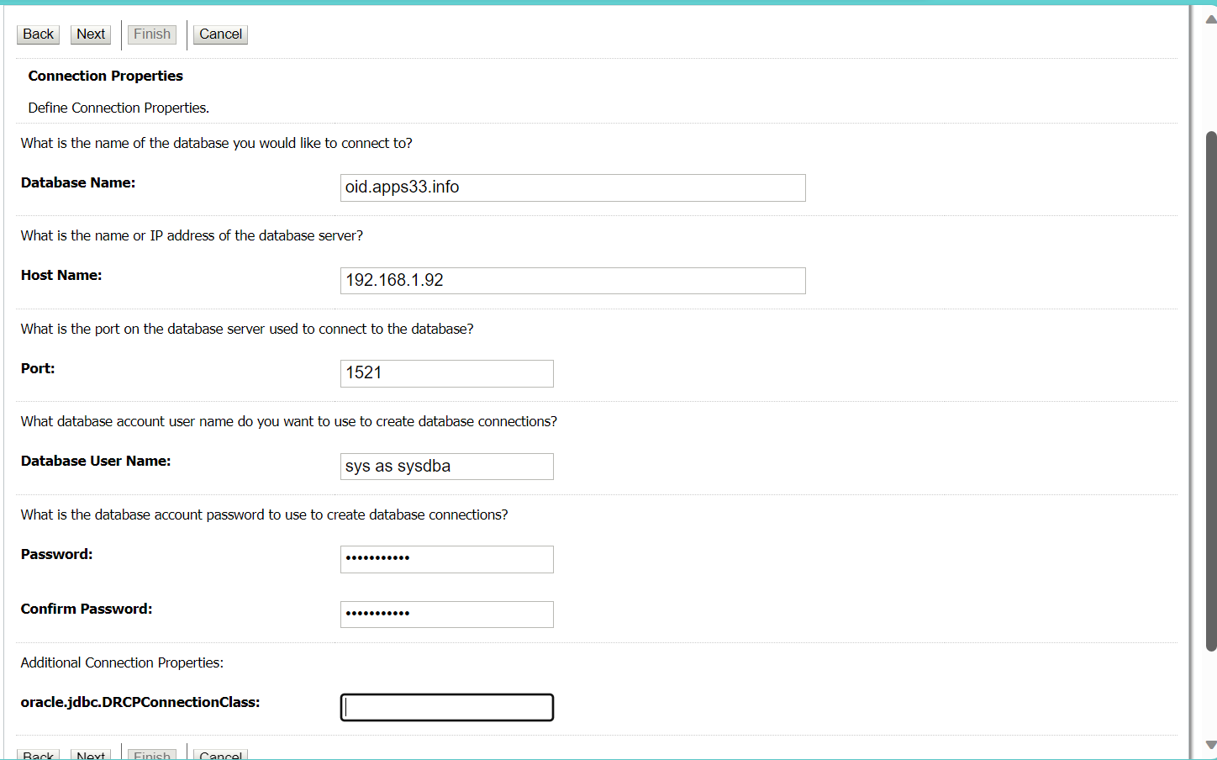

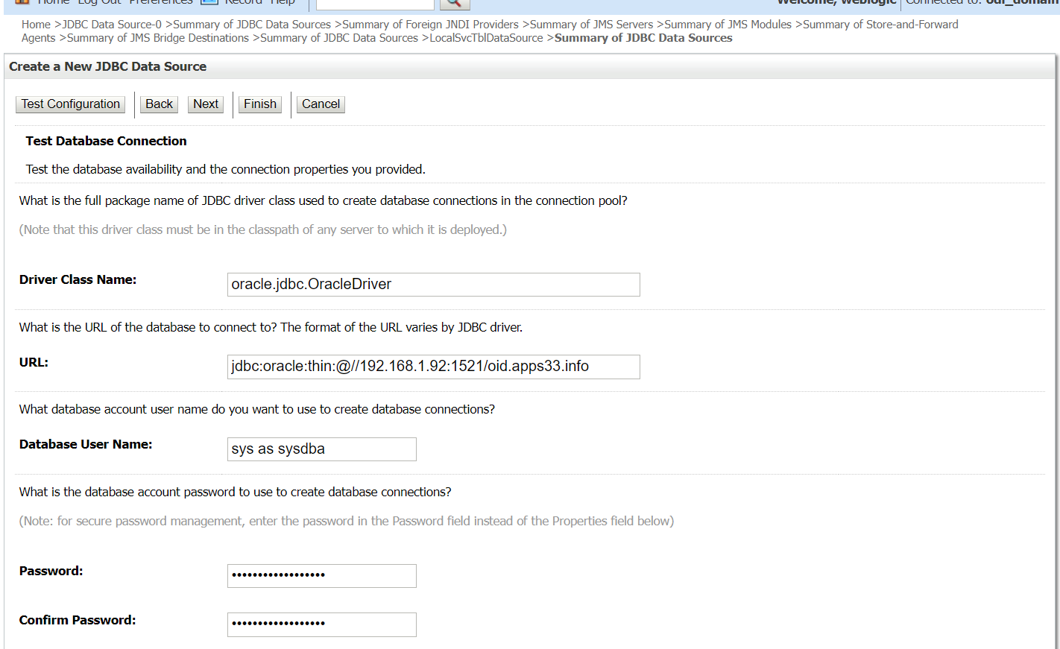

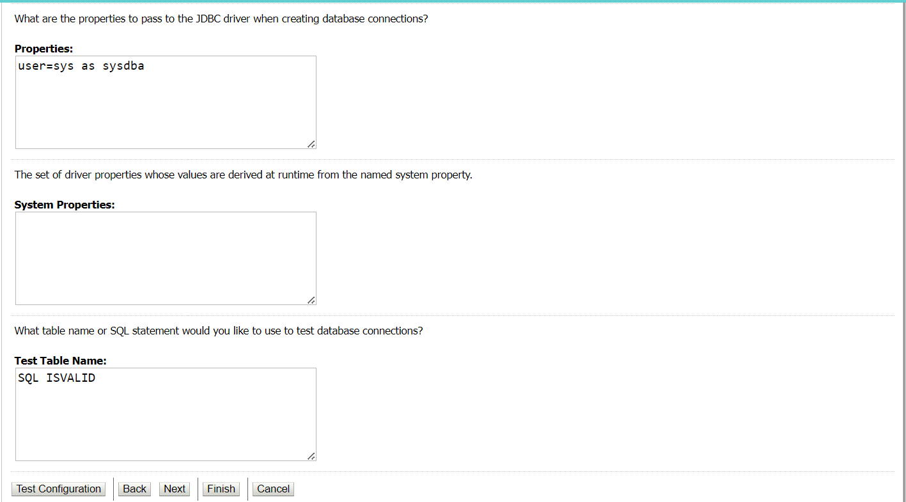

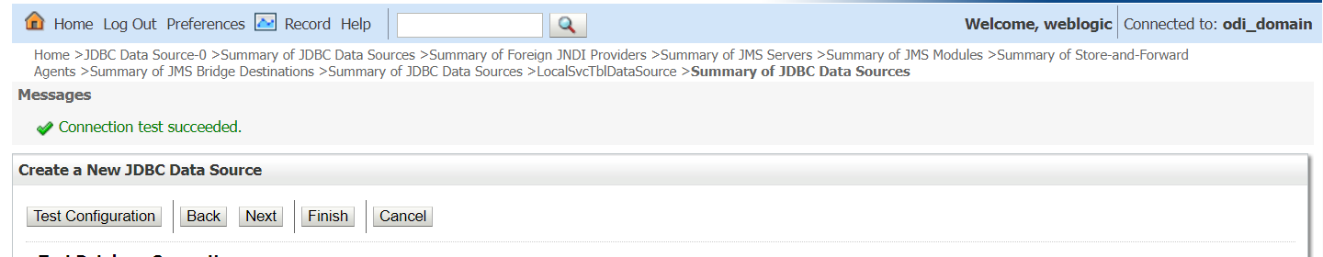

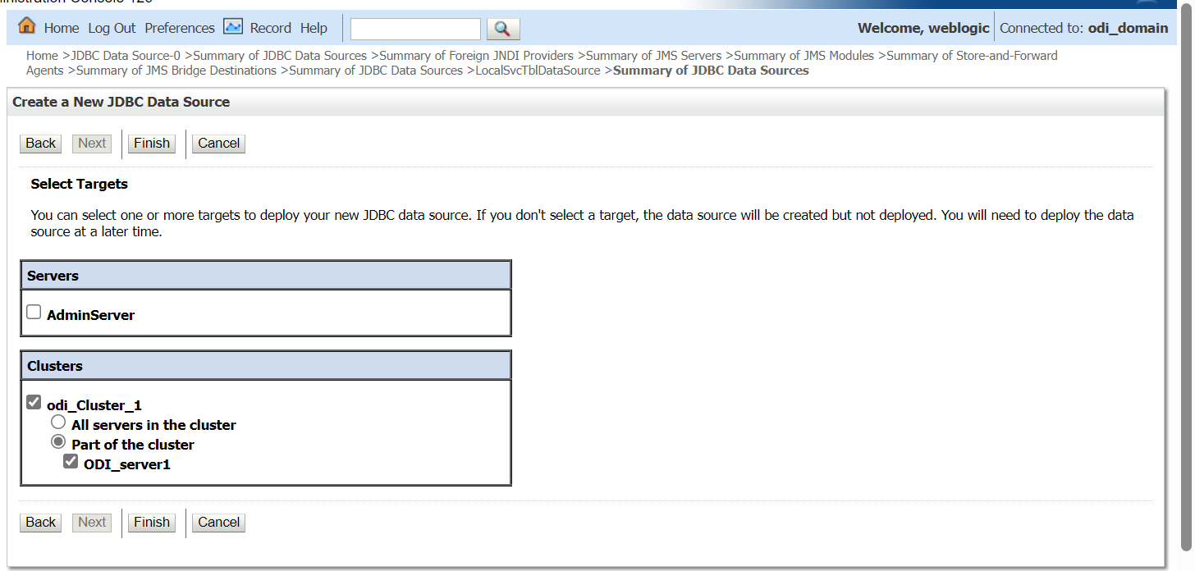

# Persistence Stores

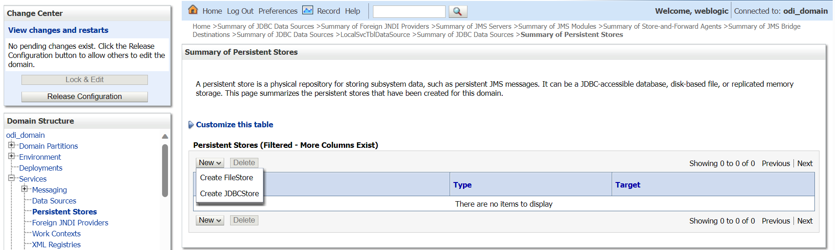

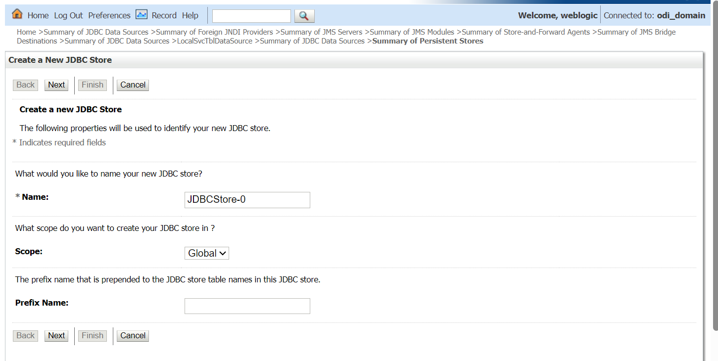

**Can Create New Data store/select Existing Store**





**Foreign JNDI Providers**

